CO-1 AT-2
CO-1 AT-2
Agile Sprint Planning & User Story Workshop
INTELLIGENT INSURANCE CLAIM
MANAGEMENT SYSTEM

Student Name: S.D. Riyaz Kamal
Register Number: 192572049
Course Code: CSA1005
Dept : CSE (A.I)
Assessment: CO1 Assessment Tool 2

1. Project Vision and Objectives
The Intelligent Insurance Claim Management System is a digital platform for submitting, verifying, assessing, approving, and settling insurance claims. It reduces paperwork and delays while keeping a clear history of every claim.

Objectives:
- Register policy details and submit claims online.
- Upload supporting documents and track claim status.
- Verify documents and assign claims to assessors.
- Record assessment results, approvals, rejections, and settlements.
- Generate basic claim analytics and preserve claim history.

2. Stakeholders
Stakeholder | Responsibility
Customer | Registers policy, submits claim, uploads files, checks status.
Claims Officer | Verifies documents and requests missing information.
Assessor | Reviews evidence and records assessment findings.
Claims Manager | Assigns claims and approves or rejects them.
Settlement Officer | Records payment and settlement details.
Administrator / Management | Controls access, configures workflow, and reviews reports.

3. System Workflow
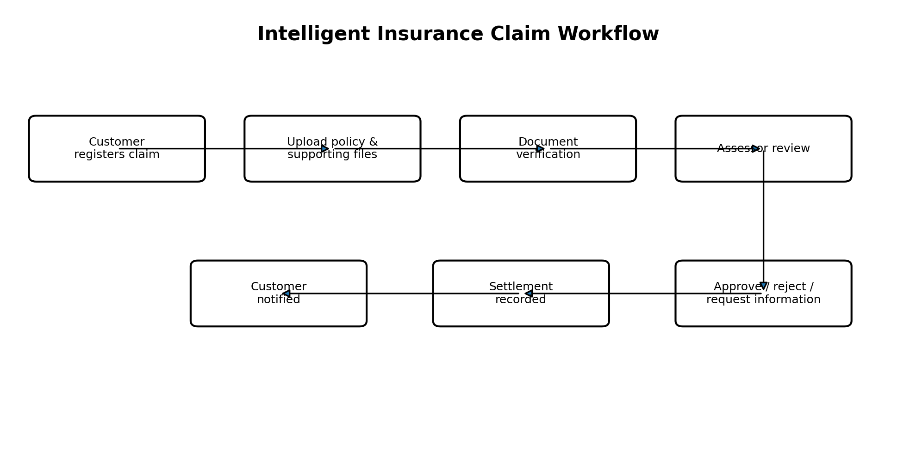
Figure 1. Claim processing workflow.

4. System Architecture
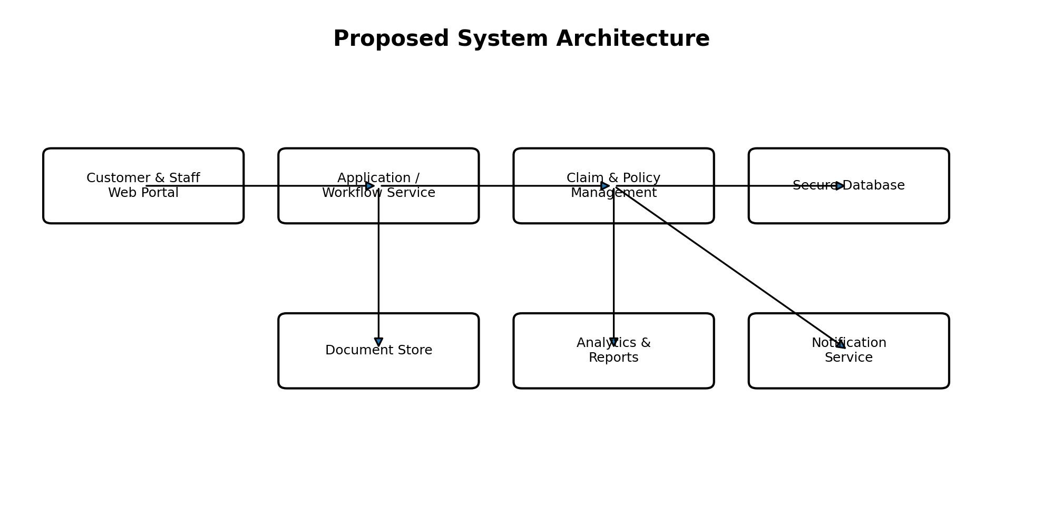
Figure 2. High-level system architecture.

5. Epics and User Stories

Epic | User Story
Policy Management | As a customer, I want to register my policy so that my coverage can be checked.
Claim Submission | As a customer, I want to submit a claim and upload documents so that the insurer can review it.
Status Tracking | As a customer, I want to view claim status so that I know the progress.
Verification | As a claims officer, I want to verify documents so that incomplete claims can be corrected.
Assessment | As an assessor, I want to record findings so that decisions are evidence-based.
Decision & Settlement | As an approver, I want to approve or reject claims, and as a settlement officer, I want to record payment details.
Analytics | As a manager, I want to view claim summaries and histories to monitor performance.

6. Acceptance Criteria

Story | Acceptance Criteria
Register policy | Given valid policy details, when the customer submits them, then the system saves the policy and confirms success.
Submit claim | Given an active policy, when required claim fields are completed, then the system creates a unique claim ID.
Upload documents | Given an existing claim, when an allowed file is uploaded, then it is linked to the claim; invalid files show an error.
Track status | Given a customer owns a claim, when they open it, then the current status and last update are displayed.
Verify / assess | Given a claim is submitted, when staff review it, then verification results and assessment findings are saved.
Approve / settle | Given assessment is complete, when an authorized user records a decision and settlement, then the decision, reason, and payment details are stored.

7. Prioritized Product Backlog
Priority | Feature | Reason
1 – High | Policy registration | Required to link claims to coverage.
2 – High | Claim submission | Core system function.
3 – High | Document upload | Evidence is needed for verification.
4 – High | Status tracking | Keeps customers informed.
5 – Medium | Verification and assessor assignment | Supports claim review.
6 – Medium | Assessment and decision | Enables approval or rejection.
7 – Later | Settlement and analytics | Completes processing and supports management.

8. Sprint Plan
Sprint duration: 2 weeks (10 working days).
Sprint goal: Build a basic working system that allows customers to register policy details, submit claims with documents, and view claim status.
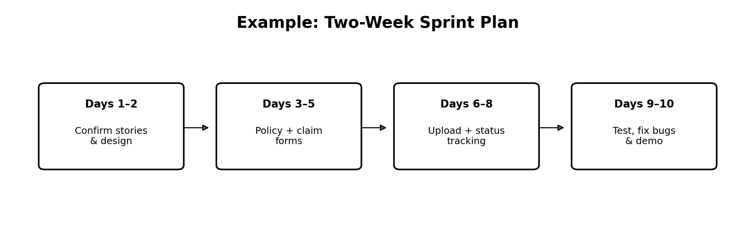
Figure 3. Example two-week sprint timeline.
Selected Story | Main Tasks | Points
Policy registration | Design fields, create table, build form, test validation. | 3
Claim submission | Create claim fields and unique ID, build form, test required fields. | 5
Document upload | Validate file types, store files, link files to claims, test access. | 5
Status tracking | Display claim list/status, store updates, test customer access. | 3
Integration and testing | Connect features, fix defects, prepare demonstration. | 3

9. Story Point Estimation
Planning Poker and the Fibonacci sequence (1, 2, 3, 5, 8, 13) are used to estimate relative effort, complexity, and uncertainty. The first sprint is estimated at 19 story points. Estimates should be adjusted to the team’s actual capacity.

10. Expected Deliverables and Outcomes
- Policy registration and claim submission forms.
- Document upload and claim status tracking.
- Basic access control and claim history.
- Test checklist, working demo, and short user guide.

11. Risks and Mitigation
Risk | Mitigation
Missing documents | Validate required fields and allow requests for more information.
Unauthorized access | Use role-based permissions and claim ownership checks.
Duplicate claims | Generate unique IDs and flag possible duplicates.
Delays or data loss | Track timestamps, maintain backups, and preserve audit history.

12. Conclusion
The proposed system digitizes the insurance claim lifecycle from policy registration to settlement. Agile epics, user stories, acceptance criteria, and sprint planning help deliver the core features first and provide a foundation for future analytics and configurable workflows.

